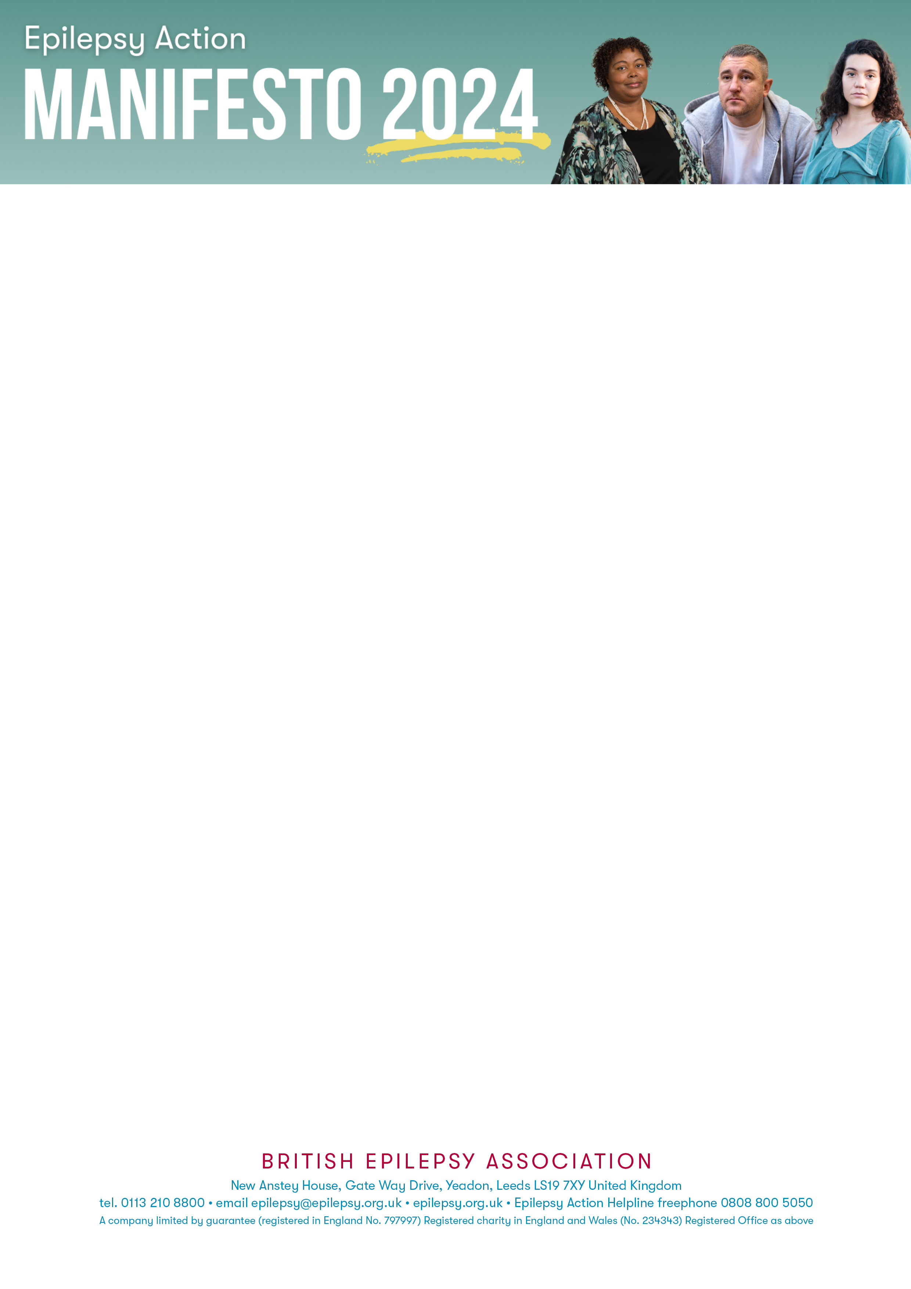
«LABEL_NAME»
«COMPANY»
«JOBTITLE»
«ADDRESS1»
«ADDRESS2»
«ADDRESS3»
«ADDRESS4»
«POSTCODE»

<Address>

Dear [Insert Name]
Epilepsy Action is a national charity that needs your help to guarantee that all people with Epilepsy are acknowledged in the 2024 political agenda and beyond.
[If you have a story you wish to share regarding your own experiences with epilepsy and Work and Benefits please write a message here – if not please DELETE this section].
We are calling on the next government to help the 630,000 people in the UK who have epilepsy. The needs of those with epilepsy have been neglected for far too long, and we ask you as representatives of the people to step up and advocate for them at this General Election.
Work and Benefits is a key area that requires significant improvement:
- Only 42% of people with epilepsy are in work, and of those who do work 60% face discrimination.
- People with epilepsy in work are paid 12% less than non-disabled peers.
- Many people with epilepsy are unable to drive as the DVLA requires people to be seizure free for 12 months. Public transport is their only option, however, over the last two years, cuts to bus and train services has left people with epilepsy isolated due to time constraints on passes.

What needs to change:
- We are calling for the Department for Work and Pensions to introduce mandatory disability employment and pay-gap reporting.
- A minimum fine for any employer discriminating against disabled employees.
- Jobcentre Plus Disability Employment Advisers to use available, skilled job coaches to support people with hidden and fluctuating conditions.
- A disabled bus pass to be available at all times of the day.
Those with epilepsy should not be discriminated against any longer, they should be able to access work and benefits to live an independent and fulfilled life and contribute to society.
Only with your help can we achieve this. Confirming your support for people with epilepsy would be very much appreciated and can help to go a long way.

