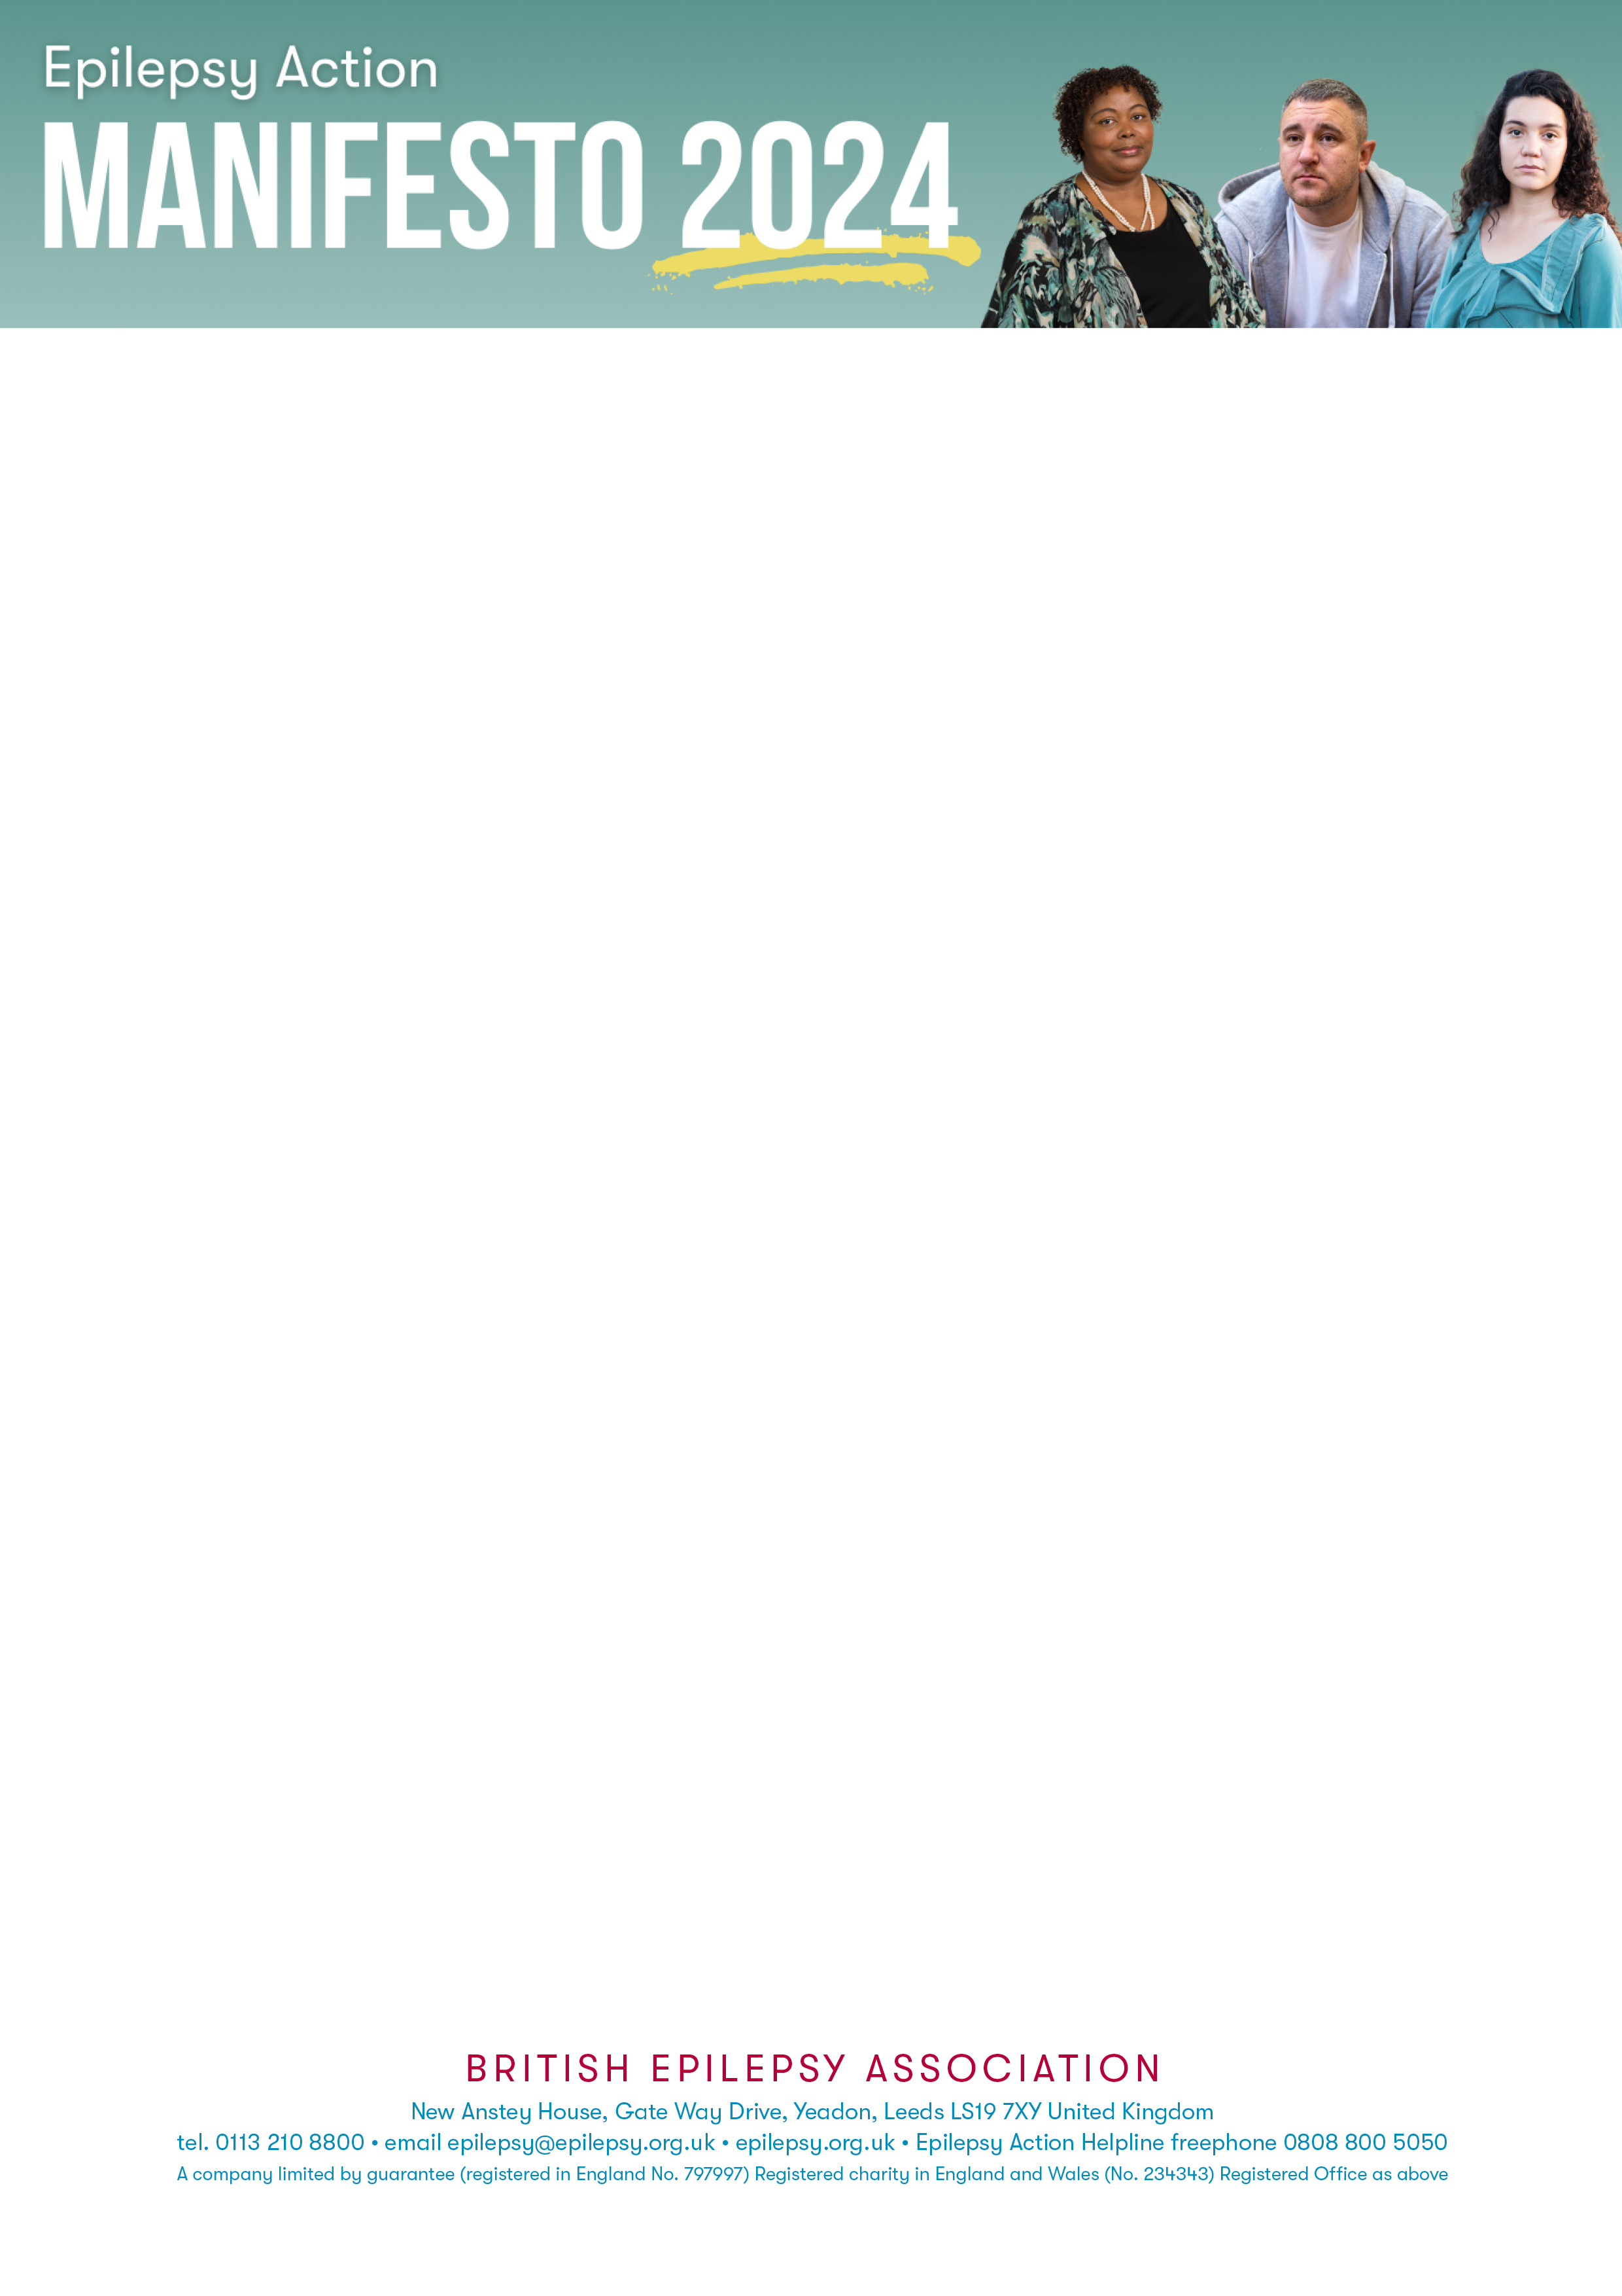
Dear [Insert Name]
Epilepsy Action is a national charity that needs your help to guarantee that all people with epilepsy are acknowledged in the 2024 political agenda and beyond.
[If you have a story you wish to share regarding your own experiences with epilepsy and Justice please write a message here – if not please DELETE this section].
We are calling on the next government to help the 630,000 people in the UK who have epilepsy. The needs of those with epilepsy have been neglected for far too long, and we ask you as representatives of the people to step up and advocate for them at this General Election.
Justice is a key area that requires significant improvement:
Families
- It is estimated that 20,000 children have been harmed by sodium valproate. Some of these children now require 24-hour care, with the government offering no support and refusing to act in helping the numerous families suffering mentally, physically, and financially each day.
Prisons and Police
- 4% of England’s prison population have epilepsy, which is more than twice that of the general population.
- In the last 18 years, 19 people with epilepsy died in UK prisons due to a lack of awareness and inappropriate management.
- Many police forces do not include a recognised risk factor for epilepsy in their missing persons policies, despite the increased risks.

«LABEL_NAME»
«COMPANY»
«JOBTITLE»
«ADDRESS1»
«ADDRESS2»
«ADDRESS3»
«ADDRESS4»
«POSTCODE»

<Address>

What needs to change:
- We ask that the future government implements the Sodium Valproate Compensation scheme.
- We are calling for a National Oversight Mechanism supporting INQUEST’s No More Deaths Campaign.
- We are calling for epilepsy awareness and first aid training to be part of mandatory training for police officers and prison staff across the UK.
- Police force missing persons policies to recognise the increased risks of having epilepsy.
Those with epilepsy should not be discriminated against any longer. Justice should be equal for everyone.
Only with your help can we achieve this. Confirming your support for people with epilepsy would be very much appreciated and can help to go a long way.

