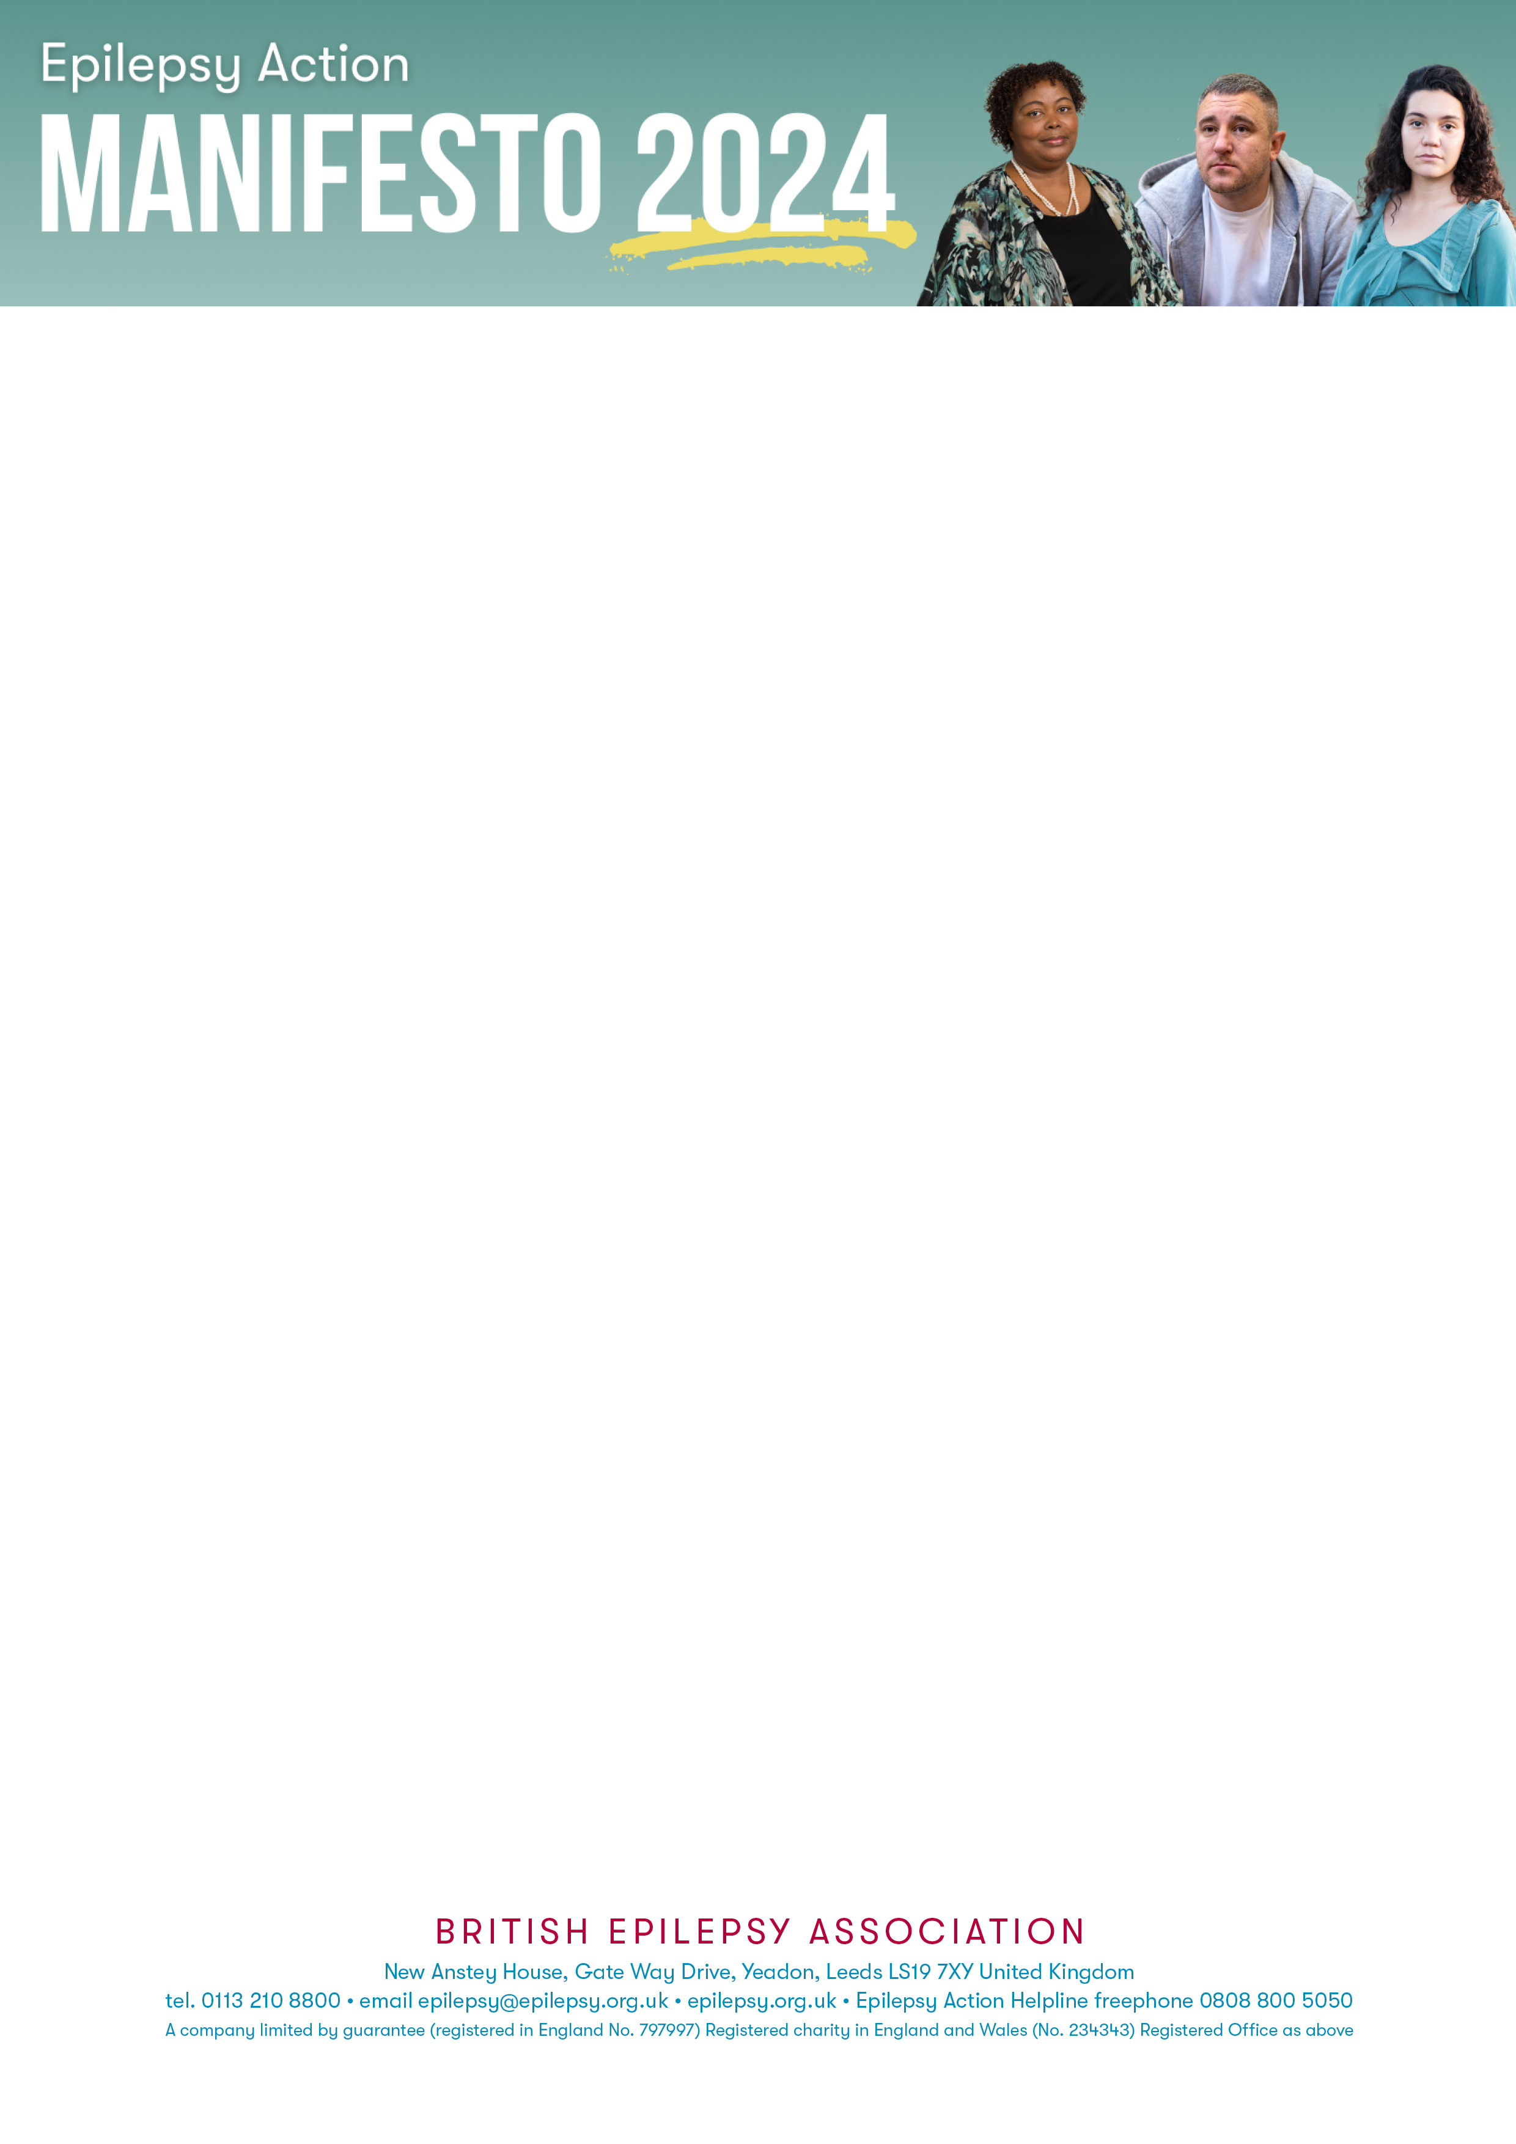
Dear [Insert Name]
Epilepsy Action is a national charity that needs your help to guarantee that all people with epilepsy are acknowledged in the 2024 political agenda and beyond.
[If you have a story you wish to share regarding your own experiences with epilepsy within Health and Social Care please write a message here – if not please DELETE this section].
We are calling on the next government to help the 630,000 people in the UK who have epilepsy. The needs of those with epilepsy have been neglected for far too long, and we ask you as representatives of the people to step up and advocate for them at this General Election.
Health and Social Care is a key area that requires significant improvement:
- The UK has one of the worst ratios of neurologists to patients. There are 1.1 full-time-equivalent neurologists per 100,000 people in the UK, whereas France and Germany have one consultant for 25,000 people or fewer.
- Over half of the neurologists in the UK are in the south-east of England but epilepsy prevalence rates in the Northeast, Northern Ireland and Wales are up to 28% higher.
- The mental health impact of those living with epilepsy is shocking according to a 2024 report from Epilepsy Action.
  - 85% reported anxiety and 70% experienced depression
  - 69% said epilepsy limited their independence
  - 50% reported feeling lonely or isolated
  - 64% waited up to six months for support

«LABEL_NAME»
«COMPANY»
«JOBTITLE»
«ADDRESS1»
«ADDRESS2»
«ADDRESS3»
«ADDRESS4»
«POSTCODE»

<Address>

What needs to change:
- Alongside the Neurological Alliance, we are calling for a national Neuro Taskforce. This will strengthen the voice of people with epilepsy. We want the Department of Health and Social Care to endorse the introduction of a Neuro Taskforce.
- We want you to support the creation of 9 regional neurology director roles to level-up neurology provision across the UK.
- Urgent investment in epilepsy and wider neurology services to reduce waiting times in line with NICE guidance.
- Recruit and develop a sustainable workforce.
- Integrated Care Boards and Integrated Care systems must ensure mental health safety is a requirement when planning transitions, services, and associated pathways, as well as mental health assessments and referrals to be regular and appropriate.
Those with epilepsy should be prioritised by the Health Service. They need to be better understood and provided for. The stats portray a situation that is unacceptable.
Only with your help can we achieve this. Confirming your support for people with epilepsy would be very much appreciated and can help to go a long way.

